Technical Test

Game

Maze Game:

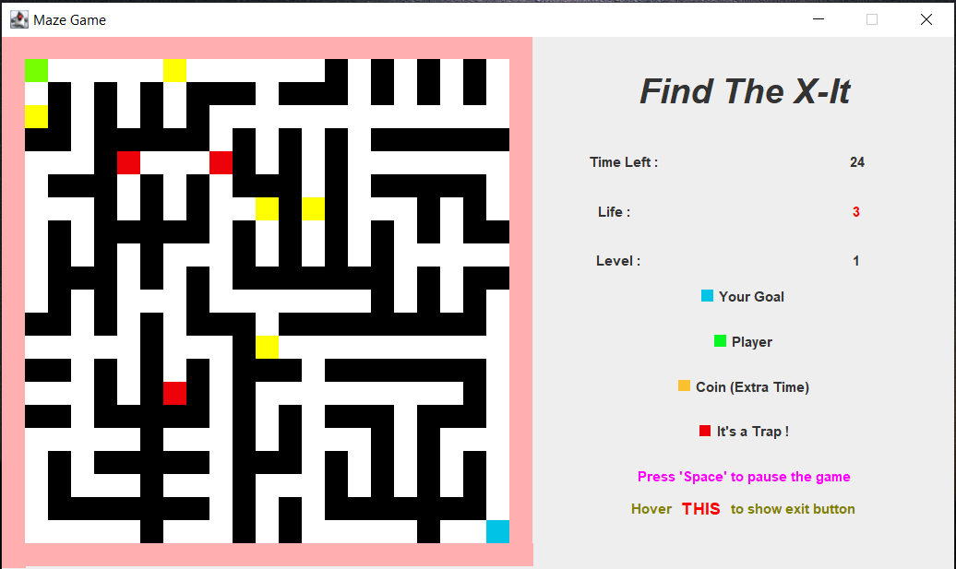

The application is created with Java Programming in Eclipse IDE. The application is a game where the player has to find the exit in a maze before the time is over. If a player runs out of time they will lose the game. The player can collect coins to increase time by 5 seconds and the player have to prevent from touching traps that can reduce their life. Each level the player is given 3 lifes, if it reaches 0, the player loses the game.

Player loses a life:

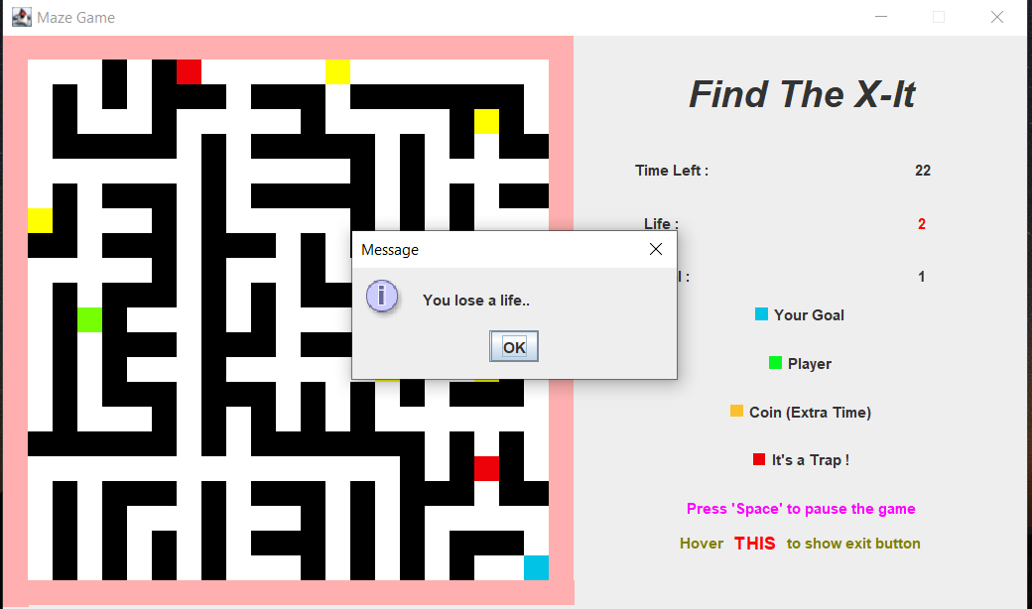

Player loses all lifes:

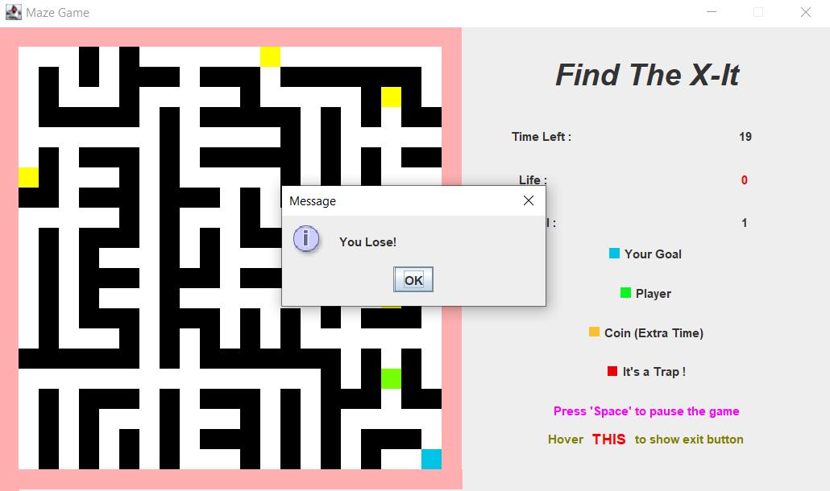

In this application the maze is generated with Prim’s Algorithm. The maze is randomized, so for every level and game there will be new maze everytime.

The location of coins and traps ae also randomized spread the paths in the maze.

If a player reaches the exit, the player will change levels.

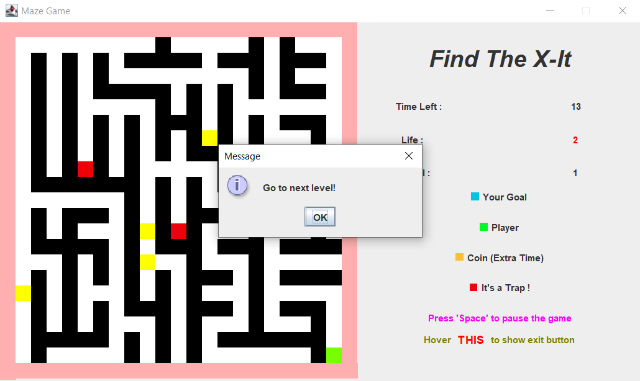

When a player levels up, the next level will have a new maze, and the timer for the new level would be the remaining time of the previous level minus by 3.

The player will win the game when they exit in the 7th level.

